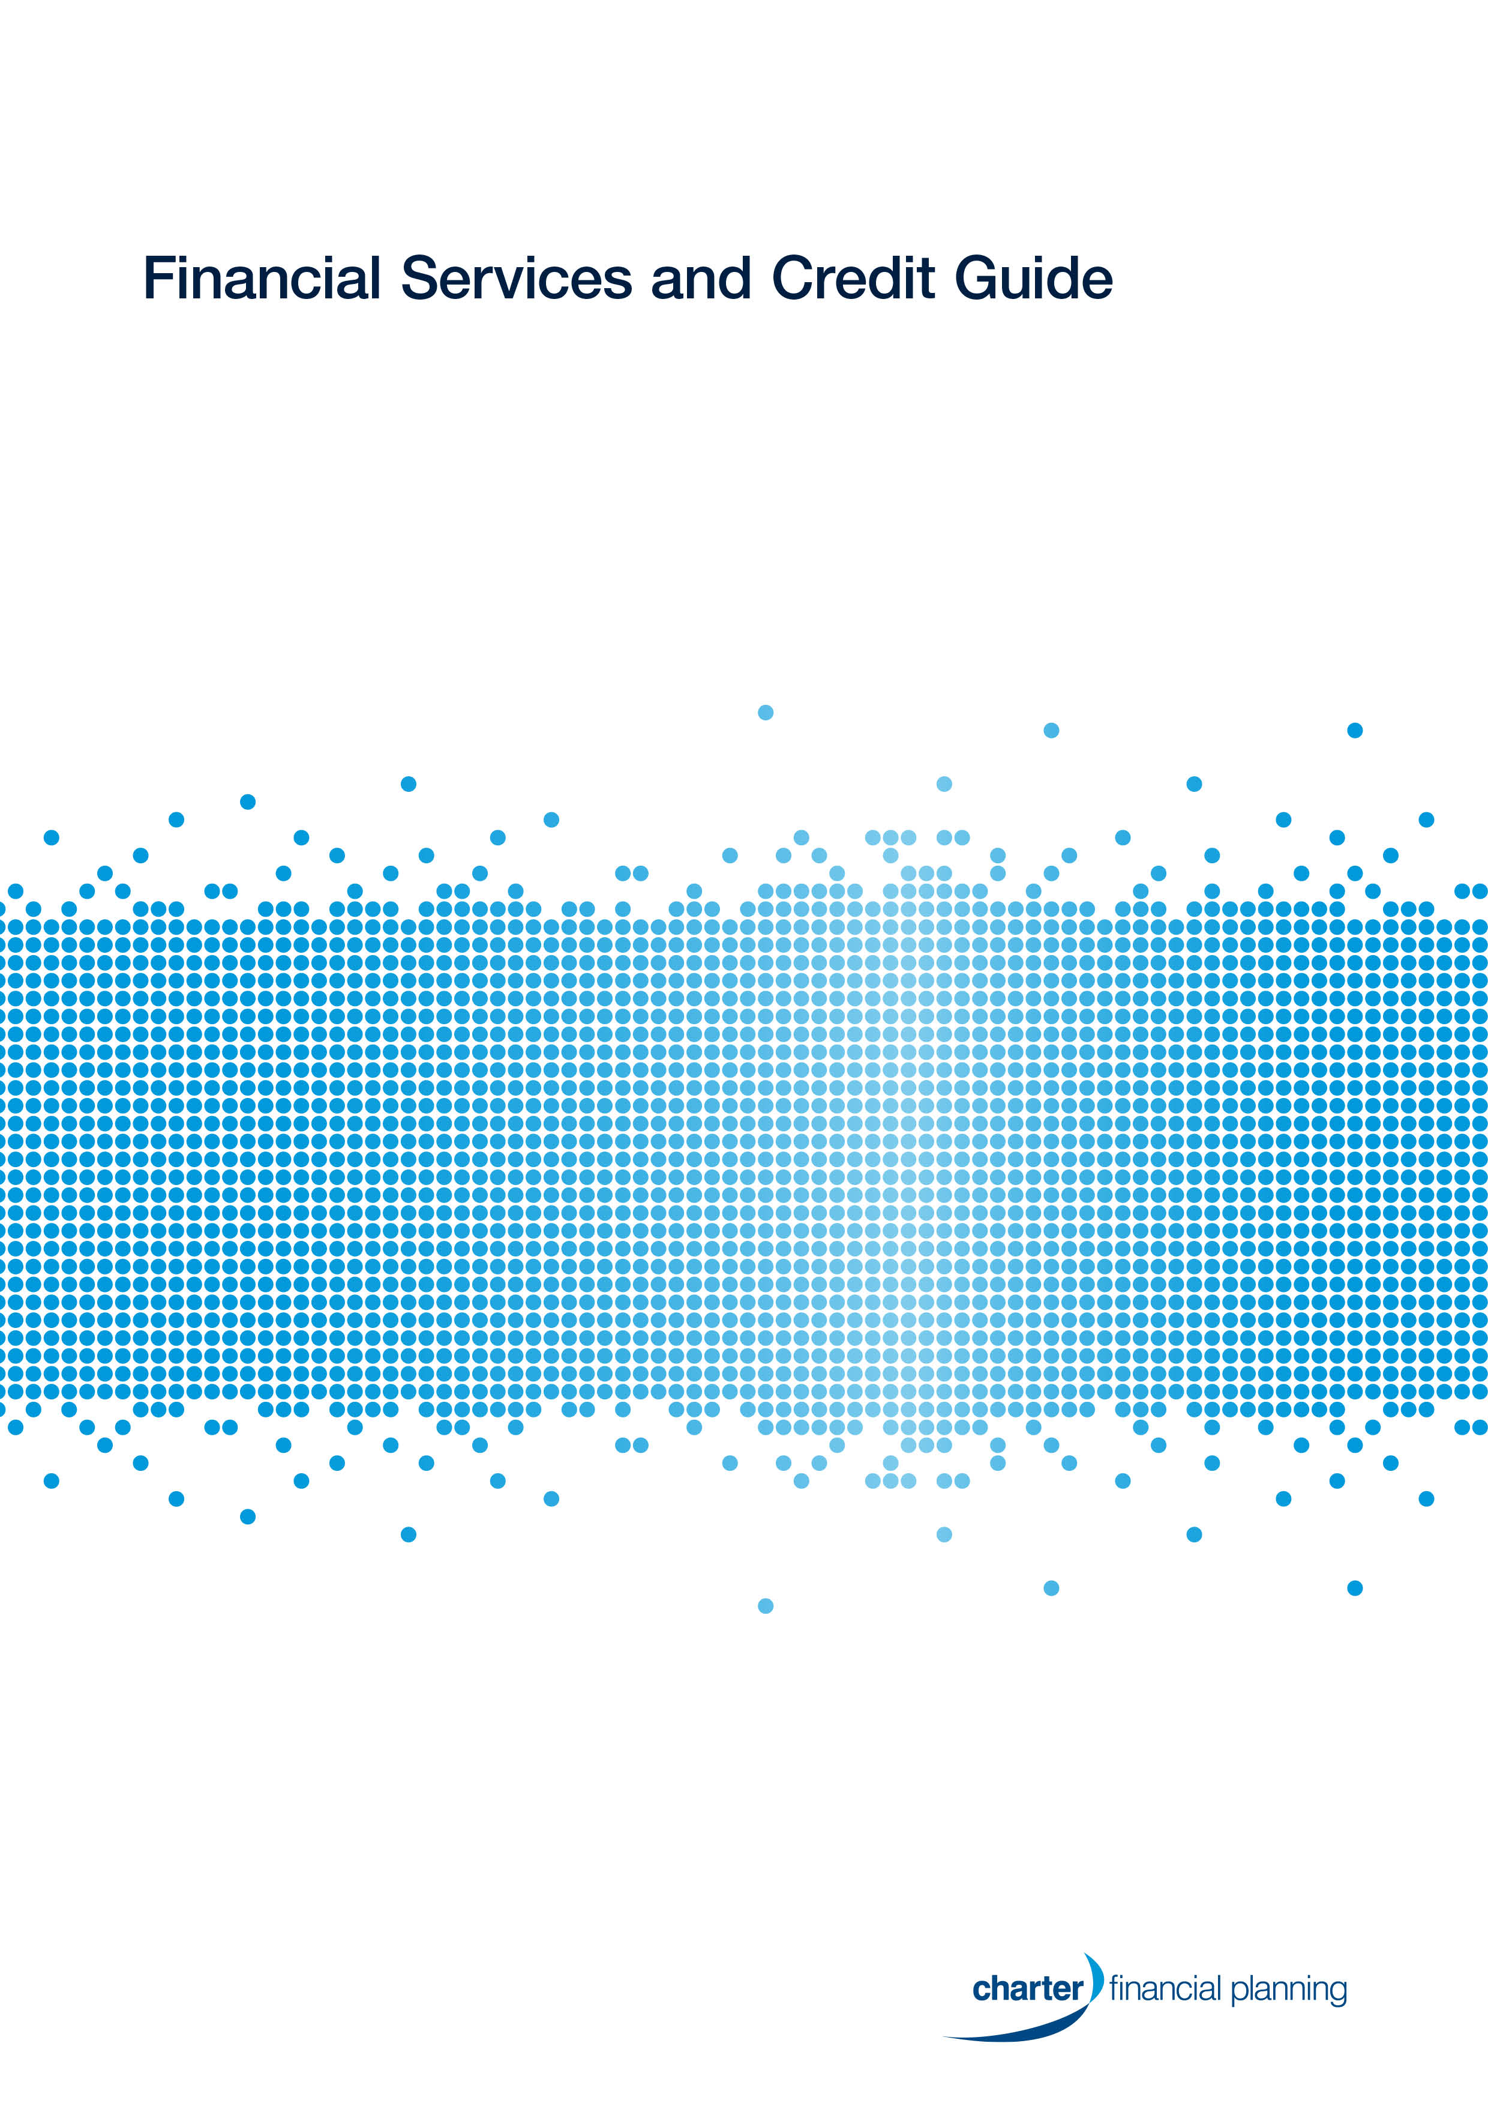
Insync Financial Solutions
It is important that you read this Financial Services and Credit Guide (FSCG). It contains information that will help you decide whether to use any of the financial services offered by us, as described in this guide, including:
- who we are and how we can be contacted
- the advice and services we provide
- information about our licensee Charter Financial Planning Limited (Charter)
- our fees and how we, your adviser and Charter, are paid in connection with those services
- how we manage your private information
- how you can complain about a matter relating to us or Charter
Documents you may receive
We will provide you with a number of documents as you progress through our financial planning process to capture each stage of your advice journey. We may provide these documents to you electronically to your nominated email address, unless otherwise agreed.
When we provide personal advice it will normally be documented and provided to you in a Statement of Advice (SoA), known as a financial plan. The financial plan contains a summary of your goals and the strategies and any financial products we may recommend to achieve your goals. It also provides you with detailed information about product costs and the fees and other benefits we and others will receive, as a result of the advice we have provided.
If we provide further personal advice a financial plan may not be required. We will keep a record of any further personal advice we provide you for seven years. You may request a copy of such records by contacting our office during that period.
If we recommend or arrange a financial product for you we will provide a product disclosure statement (PDS) or investor directed portfolio service (IDPS) guide where relevant. These documents contain the key features of the recommended product, such as its benefits and risks as well as the costs you will pay the product provider to professionally manage that product.
You should read any warnings contained in your advice document, the PDS or IDPS guide carefully before making any decision relating to a financial strategy or product.

About our practice

Summary of the business
Name | Insync Financial Pty Ltd trading as Insync Financial Solutions as Trustee of the Prenzler Business Trust
Australian Business Number | 77 208 343 273
Australian Company Number | 131 059 973
Authorised representative number | 326540
Our office contact details
Address | 63 High Street, , Boonah, Qld 4310
Phone | 07 5463 4704
Fax | 07 5463 4111
Email | info@insyncfs.com
Website | www.insyncfs.com
This guide provides information about our advisers including their contact details, qualifications, experience, the services they may offer and financial products they can provide advice on.

Our advice and services
We can provide you with personal and general advice about specific services and financial products listed below. We can also arrange for financial products to be issued without advice from us.
Individual advisers within our practice may not be qualified to provide advice in all of the services and products noted below. Their individual profile guides will note any limitations to the advice they are qualified to provide. At all times we will ensure the appropriate adviser is available to you to provide advice consistent with your goals.
The following table sets out the areas of advice we can help you with as well as the products and services we can arrange.
Any additional advice or services we can offer you, or limitations to the list below, will be outlined in Our Financial Advisers and Credit Advisers on pages 14 and 14.
We can provide advice on | We can arrange the following products and services
- Investments strategies (strategic asset allocation)  - Budget and cash flow management  - Debt management (including borrowing for personal and investment purposes)  - Salary packaging  - Superannuation strategies and retirement planning  - Personal insurance  - Estate planning  - Centrelink and other government benefits  - Ongoing advice and services, including regular portfolio reviews  - Aged care | - Superannuation, including retirement savings accounts  - Self-managed superannuation funds (SMSF)  - Borrowing within your SMSF  - Managed investments  - Deposit and payment products (for example term deposits, cash management accounts and non-cash payment products)  - Standard margin loans  - Retirement income streams, including pensions and annuities  - Personal and group Insurance (life cover, disability, income protection and trauma)  - Life investment products including whole of life, endowment and bonds  - Securities (including listed securities and debt securities)  - Exchange traded funds and Listed investment companies  - Arranging for listed securities, shares and debentures to be bought and sold via a platform and broker.  - Limited selection of investment guarantees
Charter maintains an approved products and services list, which includes products issued by AMP companies and a diversified selection of approved Australian and International fund managers. These have been researched by external research houses as well as our in-house research team.
Charter periodically reviews these products to ensure that they remain competitive with similar products that address similar client needs and objectives. Generally, we recommend products that are on the approved products and services list. However, if appropriate for your needs, we may, subject to Charter’s approval, recommend other products.
A copy of the approved products and services list can be supplied to you upon request.
If we recommend a new platform or portfolio administration service, we use those issued or promoted by the AMP Group or as otherwise approved by Charter and where appropriate to your circumstances.
The lenders and lessors whose products are most commonly recommended by Accredited Mortgage Consultants authorised by Charter are:
Lenders | - AMP Bank  - ANZ  - NAB Broker (Homeside)  - Commonwealth Bank  - Macquarie Bank  - Westpac  - ING Direct  - Suncorp  - St George Bank  - Bankwest  - AFG Home Loans | Lessors | - Macquarie  - Esanda  - Westpac  - Commonwealth Bank
Tax implications of our advice
Under the Tax Agent Services Act 2009, Insync Financial Solutions is authorised by the Tax Practitioners Board to provide tax (financial) advice services on matters that are directly related to the nature of the financial planning advice provided to you. We will not consider any other tax matters in our advice to you. Where tax implications are discussed they are incidental to our recommendations and only included as an illustration to help you decide whether to implement our advice.
Transaction services
If you do not require advice, we can also arrange for you to apply for limited types of financial products where we can take your instructions and arrange for the transaction to be completed, without providing personal advice. If you wish to proceed without our advice, we will ask you to confirm your instructions, which we will document in writing. You can ask us for a copy of this documentation at any time.
Your relationship with us and using our services
You can contact us directly with any instructions relating to your financial products. This includes giving us instructions by telephone, mail or email. We can only accept your instructions via email once you have signed an authority form.
We will work with you to agree what advice and services we will provide and when and how often we will provide them.
Where you agree to ongoing advice and services, the details will be documented and provided to you in a service agreement. This includes the frequency of contact between us, service standards that may apply, any ongoing fee arrangements and how the service can be terminated.
If at any time you wish to terminate your relationship with us, please contact us using the details shown in this guide.
Providing information to us
It is important that we understand your circumstances and goals, so that we can provide you with appropriate advice and services. You have the right not to provide us with any personal information. Should you choose to withhold information, or if information you provide is inaccurate the advice or services we provide you may not be appropriate for you.
It is also important that you keep us up to date by informing us of any changes to your circumstances so we are able to determine if our advice continues to be appropriate.

Our fees
The fees charged for our advice and services may be based on a combination of:
- A set dollar amount; or
- A percentage based fee.
Our agreed advice and service fees may include charges for:
- Initial advice; and
- Ongoing advice
Please note that for services in relation to insurance, banking deposit products, some loan products and older investment products, commissions may be paid by the product provider as follows:
- Initial commission - a percentage of the value of your investment contributions; and
- Ongoing commission - a percentage of the value of your investment balance, usually calculated at the end of each month in which you hold the investment.
Payment methods
We offer you the following payment options for payment of our advice fees:
- BPAY, direct debit (savings), credit card or cheque; and
- Deduction from your investment.
All fees and commissions will be paid directly to Charter as the licensee on our behalf. They retain a percentage (a licensee fee) to cover their costs and the balance is passed on to us. The percentage is determined annually, based on a number of factors, including our business revenue for the prior year.
For details of our service fees, see our Schedule of fees below.
Fixed service fees
We offer the following services at these fees:
Service | Fee
Initial Appointment | $330
Specialist Advice | $385 per hour
Additional Advice | $330 per hour
Other costs
Where other costs are incurred in the process of providing our advice and services to you, you will be liable for these costs. However, we will agree all additional costs with you prior to incurring them.
Other benefits we may receive
The following is a list of benefits we may receive other than those explained above. These are not additional costs to you. These benefits may be monetary or things like training, events or incentives we are eligible for.
In addition to the payments we may receive for our advice and services, we may receive other support services. These can include financial and training assistance, prizes and awards or events in recognition of financial planning excellence and innovation, and business performance.
We may also participate in business lunches or receive corporate promotional merchandise tickets to sporting or cultural events and other similar items.

Development, management and advice recognition
We may qualify to receive a DMA to recognise and reward our growth and professionalism. The DMA is based on a rate, calculated once per year, and determined by our ranking relative to other Charter Financial Planning practices. Up to 50% of all Charter Financial Planning practices may qualify for DMA payments. The rate may range from 0% to 3.25%, depending on our ranking. It is then applied to our practice revenue of the prior year and paid to us in two instalments a year.
For example, if our DMA is set at 1% and our revenue for the prior year was $200,000, we would receive a total of $2,000 for that year, paid over two instalments.
How our performance is ranked
Our practice ranking is based on a scorecard, with points received for the quality of our services, compliance (audit results), our business goals and our engagement with clients through a measure called Advice Growth Index (AGI). AGI measures the value of our fee for service payments and our clients’ product holdings over the previous year.
Value participation scheme
AMP will provide us a cash payment based on the total in force annual premiums on some AMP insurance products and funds under management in some AMP wealth management products. The amount paid is based on the following:
- A tiered rate of up to 3% is applied incrementally to total premiums on some AMP insurance products. For example, if a client takes out a qualifying AMP insurance policy with an annual premium of $3,000, we may receive an annual payment of up to $90 in respect of that policy, with the rate applied dependent on the total combined premiums from all qualifying AMP insurance products.
- A tiered rate of up to 0.25% is applied incrementally to the total funds under management in qualifying AMP wealth management products. For example, if an existing client with a qualifying AMP wealth product invests a further $40,000 into that product, we may receive up to $100 in respect of that specific investment, with the rate applied dependent on the total qualifying funds under management.
From 1 July 2014, all investments in AMP wealth management products by new clients have been excluded from the scheme.
Certified quality advice program
On meeting eligibility criteria and gaining access into the program, we may be eligible for discounts on practice fees, as well as an increased purchase price under the buyout option. Eligibility is assessed on professional operations and processes, high quality advice standards and education.
Buyout option
We are eligible to sell the register rights of our client base to Charter. The value of the sale is based on a multiple of the ongoing revenue generated from financial products.
Annual advice conference
The advice conference is an annual event which offers advisers the opportunity for professional development and to hear updates on AMP’s thinking about the future of advice. Charter subsidises the costs of the advisers attending. The value will depend upon a range of factors, including the nature of the courses and events planned.
Educational support
Charter Financial Planning rewards individuals with educational support if they meet certain qualifying criteria. The qualifying criteria may vary, and is normally based on the standard of our financial planning services and our business performance.
Business support
We might receive financial assistance including subsidies or reimbursements for accounting, legal and bank fees; marketing or other once-off transitional support costs, to help us grow our business or implement appropriate succession planning options.
Placement fees
From time to time Charter will receive fees from brokers or product issuers (including AMP group companies) for arranging client participation in Initial Public Offerings (IPOs) of securities (such as shares and rights issues). The fee, which is generally a percentage of the fee paid to the broker, varies from offer to offer and by the level of participation by Charter. We may share in this fee based on the level of participation by our clients.

Relationships and associations
It is important that you are aware of the relationships that Charter has with providers of financial services and products as they could be seen to influence the advice you receive.
About our licensee
Charter Financial Planning Limited
ABN 35 002 976 294
Australian Financial Services Licensee and Australian Credit Licensee No: 234665
Charter is a member of the AMP Group and has:
- Approved the distribution of this guide
- Authorised us to provide advice and other services as described in this guide
- Authorised us to provide credit assistance services to you
Charter’s registered office is located at 33 Alfred Street, Sydney, NSW 2000.
About the AMP Group
Charter is a member of the AMP group of companies. We can provide advice on products from a wide range of financial product providers, some of which are part of the AMP Group and as such Charter is affiliated with:
- The National Mutual Life Association of Australasia Limited*  - National Mutual Funds Management Limited  - NMMT Limited  - N.M. Superannuation Pty Limited  - Multiport Pty Limited  - ipac asset management limited  - AMP Bank Limited | - AMP Capital Funds Management Limited  - AMP Capital Investors Limited  - AMP Superannuation Limited  - AMP Life Limited  - Cavendish Superannuation Pty Ltd  - Australian Securities Administration Limited (ASAL)  - Super IQ Pty Ltd
*The National Mutual Life Association of Australasia Limited will cease issuing products on 31 December 2016. On 1 January 2017, the life insurance business of this company will transfer to AMP Life Limited.
If we recommend a product issued by the AMP Group or a third party product issuer, they will benefit from our recommendation by receiving product, administration and investment fees, as well as fees paid by fund managers to distribute their product. These fees are all disclosed in the relevant PDS or IDPS guide.
Authorised representatives and/or staff employed in our business may hold shares in AMP Limited, whose share price may be favourably affected by the sale of products issued by AMP Group companies.
Charter’s relationships with other companies
Issuers of products do not pay to be included on the approved products and services list.
Product issuers or service providers that have been selected for inclusion may pay AMP Services Limited the following benefits up to the following amounts (these are all inclusive of GST):
- A fixed payment of up to $495,000 for risk insurance products.
- A fixed payment of up to $195,000 for investment products.
Our practice does not receive any part of these payments. From time to time, product issuers have access to Charter and its authorised representatives to provide education as well as give training on their products.

Confidence in the quality of our advice
If at any time you feel like you are not satisfied with our services, the following will help you understand your options and find a resolution.
- Contact your adviser and tell them about your complaint.
- If your complaint is not satisfactorily resolved within three days, please contact AMP Advice Complaints on adviceComplaints@amp.com.au, or put your complaint in writing and send it to:
Attention: National Manager, Advice Complaints
Level 12, 33 Alfred Street
Sydney NSW 2000
- AMP Advice Complaints will try to resolve your complaint quickly and fairly.
- If your complaint has not been resolved satisfactorily, you may escalate your complaint to one of the following External Dispute Resolution Schemes listed in the following below.
Any issues relating to financial advice, investments, superannuation or insurance matters | Financial Ombudsman Service (FOS)  GPO Box 3  Collins Street West  Melbourne VIC 3001  1300 780 808  www.fos.org.au  info@fos.org.au
Any issue relating to your personal information | The Privacy Commissioner  GPO Box 5218  Sydney NSW 2001  1300 363 992  privacy@privacy.gov.au
You may also contact the Australian Securities & Investments Commission (ASIC) on 1300 300 630 (free call info line) to make a complaint and obtain information about your rights. You can also contact the Financial Planning Association (FPA) at http://www.fpa.asn.au to make a complaint (please note that the FPA cannot award compensation).
Professional indemnity insurance
We maintain professional indemnity insurance to cover our advice and the recommendations provided by your adviser. Charter is also covered by professional indemnity insurance and this satisfies the requirements imposed by the Corporations Act 2001 and National Consumer Credit Protection Act. The insurance covers claims arising from the actions of former employees or representatives of Charter, even where subsequent to these actions they have ceased to be employed by or act for Charter.

Your privacy
Your privacy is important to us. Below we outline how we maintain the privacy of the information we collect about you.
Privacy Collection Statement
As part of the financial planning process, we need to collect information about you. Where possible we will obtain that information directly from you, but if authorised by you we may also obtain it from other sources such as your employer or accountant. If that information is incomplete or inaccurate, this could affect our ability to fully or properly analyse your needs, objectives and financial situation, so our recommendations may not be completely appropriate or suitable for you.
We are also required under the Anti-Money-Laundering and Counter-Terrorism Financing Act (AML/CTF) 2006 to implement client identification processes. We will need you to present identification documents such as passports and driver’s licences in order to meet our obligations.
We keep your personal information confidential, and only use it in accordance with our Privacy Policy. Some of the ways we may use this information are set out below:
- Your adviser and Charter may have access to this information when providing financial advice or services to you;
- Your adviser may, in the future, disclose information to other financial advisers, brokers and those who are authorised by Charter to review customers' needs and circumstances from time to time, including other companies within the AMP group;
- Your information may be disclosed to external service suppliers both here and overseas who supply administrative, financial or other services to assist your adviser and the AMP group in providing financial advice and services to you. A list of countries where these service providers are located can be found in the AMP Privacy Policy;
- Your information may be used to provide ongoing information about opportunities that may be useful or relevant to your financial needs through direct marketing (subject to your ability to opt-out as set out in the AMP Privacy Policy);
- Your information may be disclosed as required or authorised by law and to anyone authorised by you.
Your adviser and Charter will continue to take reasonable steps to protect your information from misuse, loss, and unauthorised access, modification or improper disclosure. You can request access to the information your adviser or Charter holds about you at any time to correct or update it as set out in the AMP Privacy Policy. The AMP Privacy Policy also contains information about how to make a complaint about a breach of the Australian Privacy Principles.
For a copy of AMP's Privacy Policy visit http://www.amp.com.au/privacy or you can contact us.

Our Financial Advisers and Credit Advisers
About Darryl Prenzler
Experience | Industry Experience since May 2003.
Qualifications | Diploma of Financial Planning,  Advanced Diploma of Financial Planning - Adv.Dip.FS (FP), Adv. Diploma in Bus Management, Adv. Diploma in Agriculture (Rural Bus Management)
Memberships | AFA
Phone | 07 5463 4704
Email | darryl@insyncfs.com
Authorised representative number | 250537
Credit representative number | 407301
The advice and services I can provide
I am authorised to provide all the services listed in the Our advice and services section.
I am also a Credit Representative of Charter and am authorised to provide credit advice regarding how to structure debt, suitability of existing loan structures and repayment options. If you require advice involving mortgages or other lending products, I can refer you to an Accredited Mortgage Consultant.
How I am paid
I receive the following from our practice:
- salary
- bonus
- equity in the practice
Darryl Prenzler is paid a salary and bonuses from Insync Financial Pty Ltd as trustee for Prenzler Business Trust and also has equity in the business which may result in him receiving additional capital and profit related benefits.

About Cameron Stewart
Experience | Industry experience since October 1998.
Qualifications | Diploma of Financial Planning, Advanced Diploma of Financial Planning - Adv.Dip.FS (FP), BSc., CDec.
Memberships | AFA
Phone | 07 5463 4704
Email | cameron@insyncfs.com
Authorised representative number | 248388
Credit representative number | 470535
The advice and services I can provide
I am authorised to provide the services listed in the Our advice and services section of this guide, except for the following:
- Gearing and margin lending
- SMSF borrowing
Should you require advice and services that extend beyond my authority I can refer you to a suitably qualified adviser.
I am also a Credit Representative of Charter and am authorised to provide credit advice regarding how to structure debt, suitability of existing loan structures and repayment options. If you require advice involving mortgages or other lending products, I can refer you to an Accredited Mortgage Consultant.
How I am paid
I receive the following from our practice:
- salary
- bonus where pre-determined criteria are met
Cameron Stewart is paid a salary from Insync Financial Pty Ltd as trustee for Prenzler Business Trust and does not earn any fees, commissions or brokerage, but may receive bonuses and other benefits when certain criteria such as achieving revenue targets are met.

